Logbook Week 7
March 3, 2026

On the seventh week we:
- Finally got the measurements for the hole grid on our table! Now we can start building our substations to the hole specifications. We needed to do this in this order because they substations must be designed to mount on the table. The professor got us a sketch of the dimensions for mounting the base of the UR3e robot, which gave us the dimensions between the holes (because the robot was already mounted on the table). The spaces between holes ended up being the diameter of the robot base divided by half, so 55mm. So all I had to do was measure dimensions of the first hole relative to the edges of the table, count the holes in both directions, and use the hole and linear pattern tools on Onshape to make it in CAD.
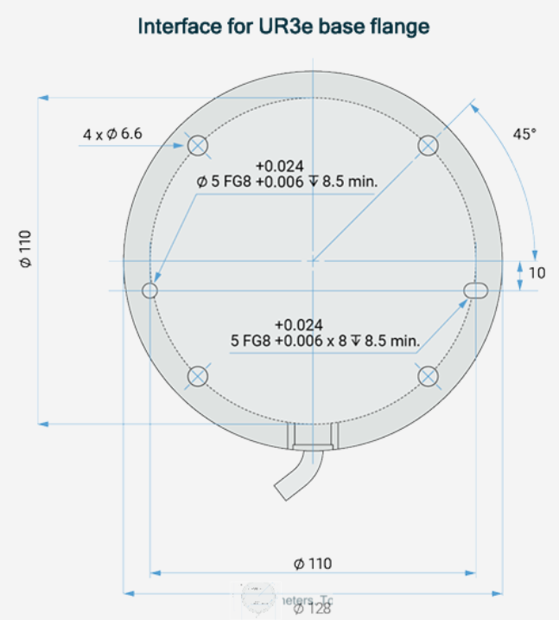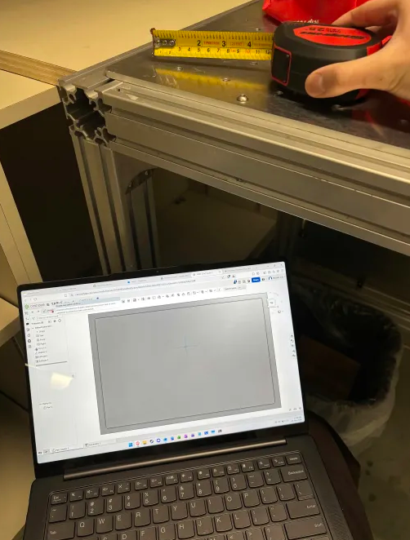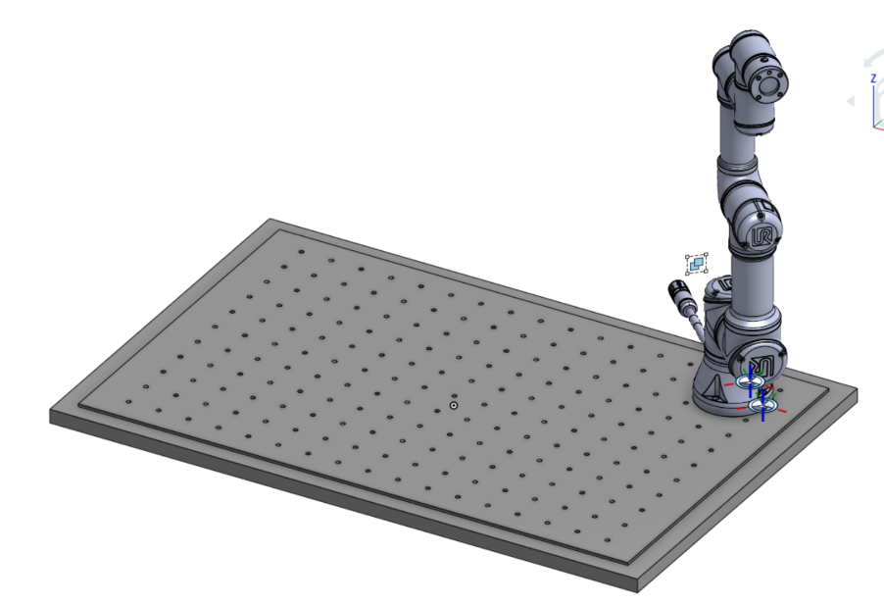
- We still need to figure out the screw/thread size for the holes. It is important for when we build it, but for now, just for CAD purposes, I made the holes a random size because they are only there for mating things together to them in the assembly. As you can see in the picture, I already mated the UR3e robot to the table through its screw holes.
- We also bought the rollers for the rice dispensing machine already. We felt like we needed these first since we planned to get them from the dollar store, and then design the rest of the substation around it. A problem we immediately ran into was the question of how we were going to attach a motor shaft to it. The shaft the roller comes with is designed to be loose so that the roller can… well, do its job. But for our application, we need a rigid shaft (no revolution allowed) so that its movement can be directed by a motor.
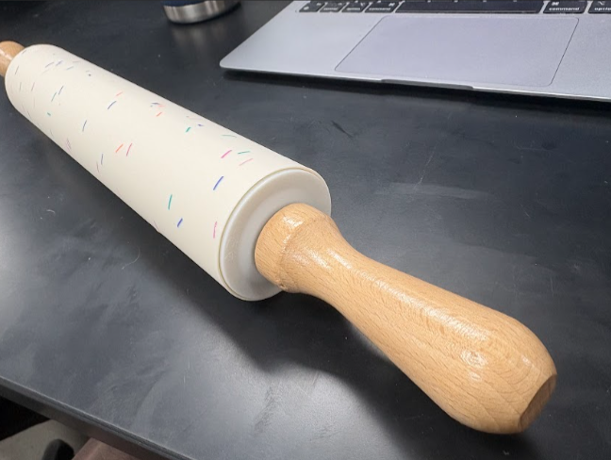
- We also searched for spare parts around the ETB basement that we can use for our mechanical assembly so that we can save money. With the help of the professor, we discovered a significant amount of spare extrusions. We plan to use them and have already claimed them. These extrusions can be easily mounted to our table with screws and nuts—one of them inserts into the V or T slots of the extrusion and the other fastens it from the other side.
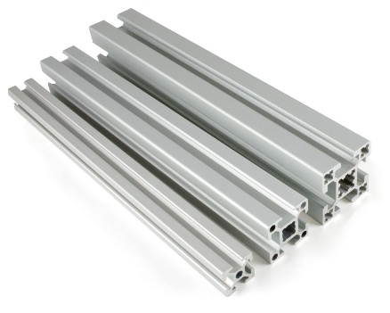
- The problem was they were mostly T slot extrusions, so we tested them with our linear slide platform. We discovered a drawer full of tools at the end of the room that we could use. We took apart our linear slide and tested the new extrusions. Unfortunately they did not work together. But it does not mean we can’t use the extrusions for something else, for the other substations.

- We also mostly worked on the midterm update deliverable this week, both the presentation slides and the document report. I worked on the “What We Achieved So Far” slides of the presentation and some sections of the report:
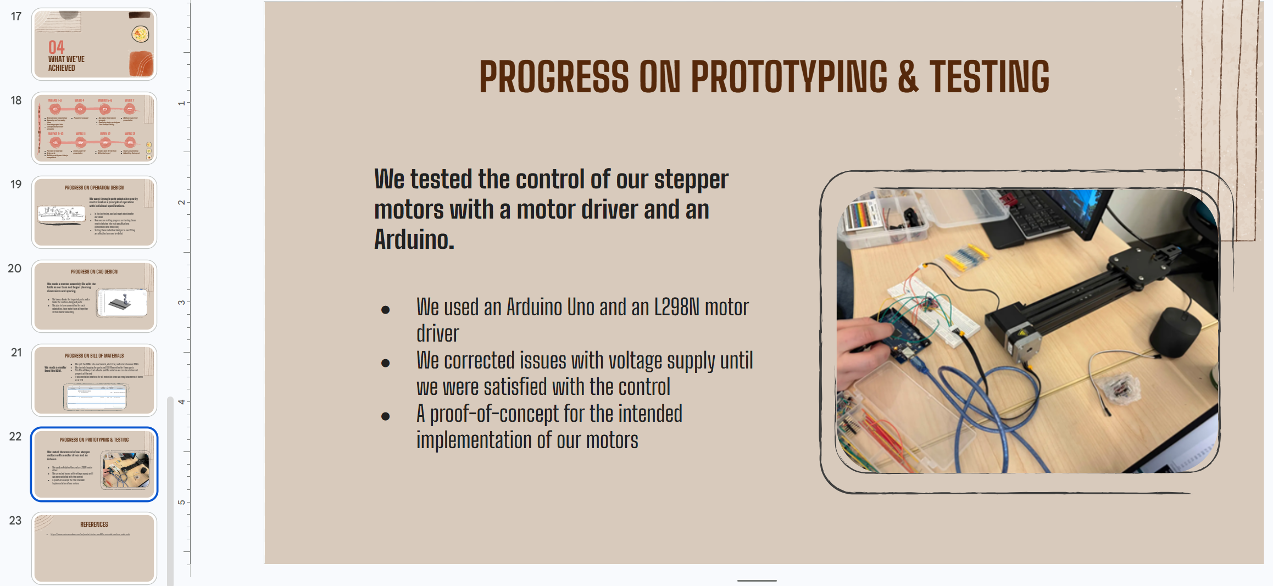
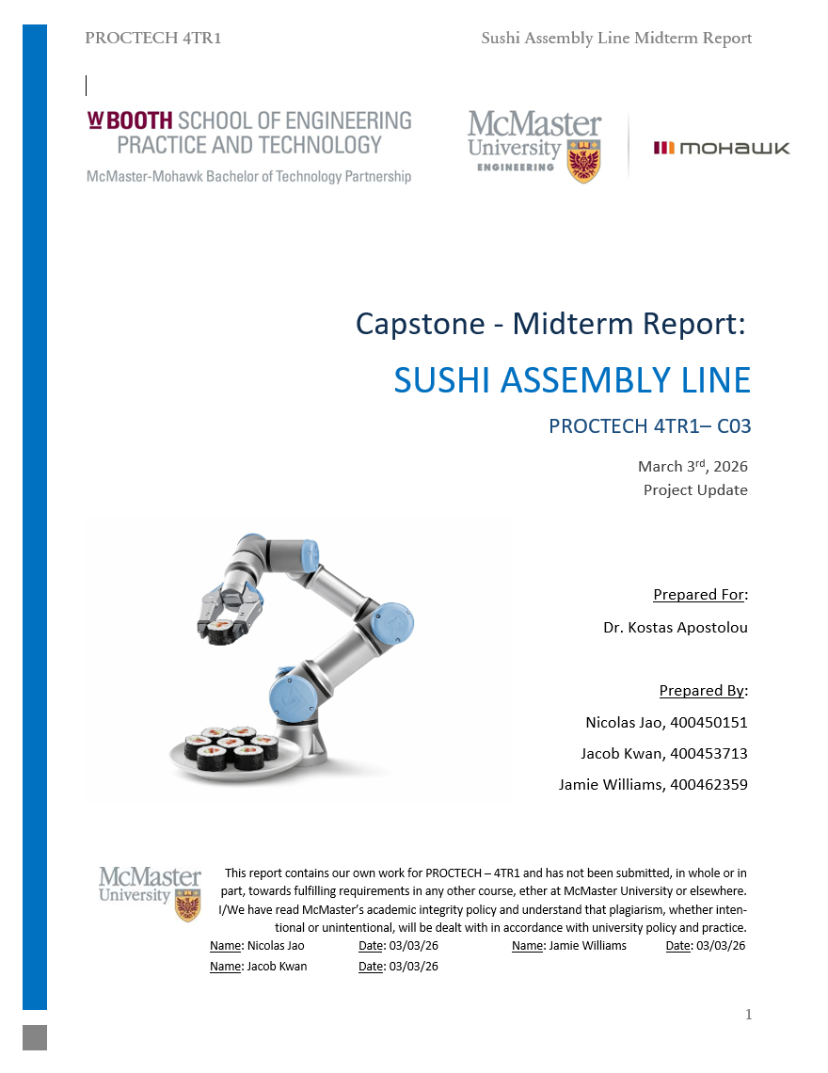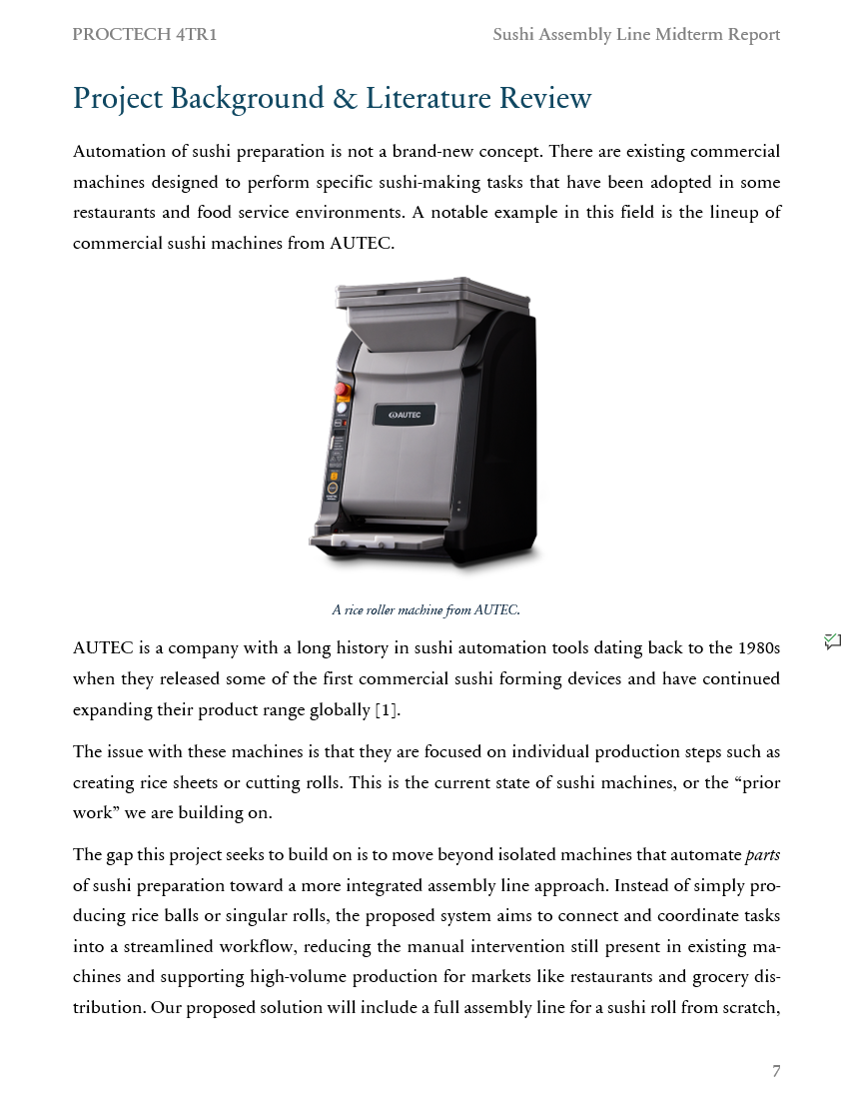

Here is a state diagram of our system that Jacob made for our report:
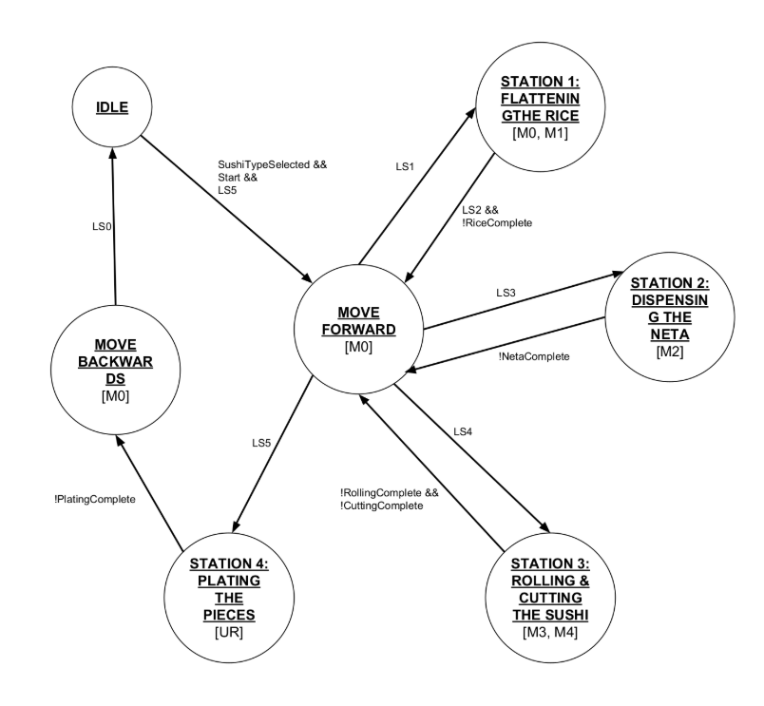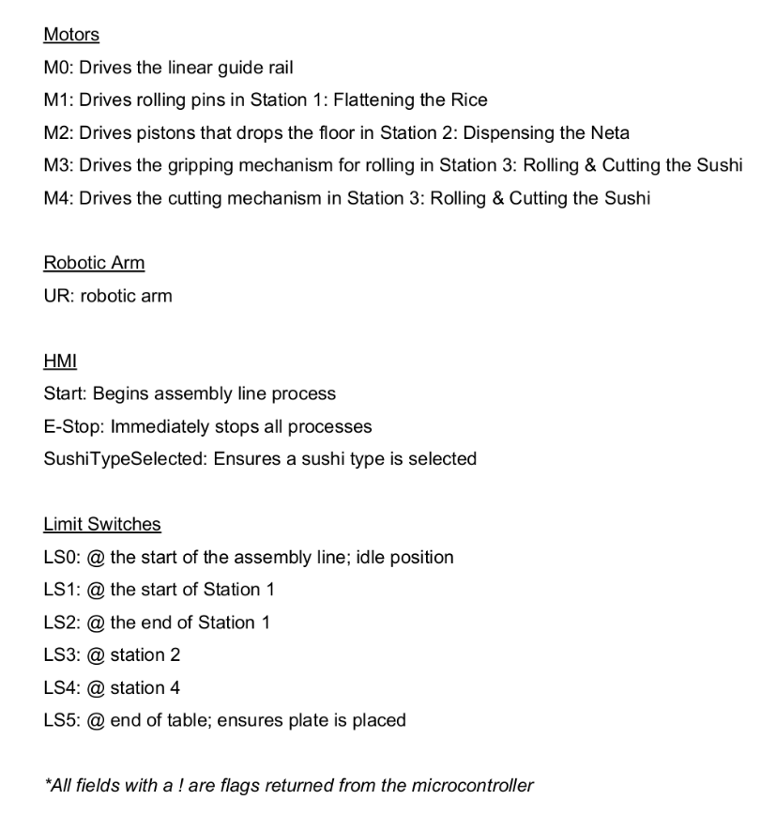

Things we will work on next week:
- Jacob wants to start dedicating time to learning how to program our UR robot. (This task is continued from last week.)
- I want to finalize motor part numbers and start importing them into our CAD so that we can start designing the mechanical assembly of our substations. I will also need to research and find where we can buy parts for the mechanical assembly. (This task is continued from last week.)
- I will also start importing more things into CAD and start designing substations. The one we want to focus on next week is the linear slide, or station 0. This is because it is the base for the entire system and we need to get the length specified for the extrusion and belt so that we can plan the spacing for the rest of the substations. Once the linear slide is done in the CAD, we will move onto designing the rice dispensing substation.
- I want to figure out (with the help of my group members) the screws and nuts we are going to use to mount the extrusions and everything else in our mechanical assembly so that I can finalize putting them in our BOM and perhaps start ordering them.

